|  |
| --- |
| Date/Location |
| 04/08/2022 @Zoom, 2:00 – 3:00 PM |

|  |  |
| --- | --- |
| Attendees | |
| Client | MAVDEV |
| Joe Saceric | Ammar Lokhandwala |
| Umera Khan | Michael Gurch |
|  | Victoria Sheraden |

|  |
| --- |
| Meeting Agenda |

1. **Current Trello Board**

For Meetings:

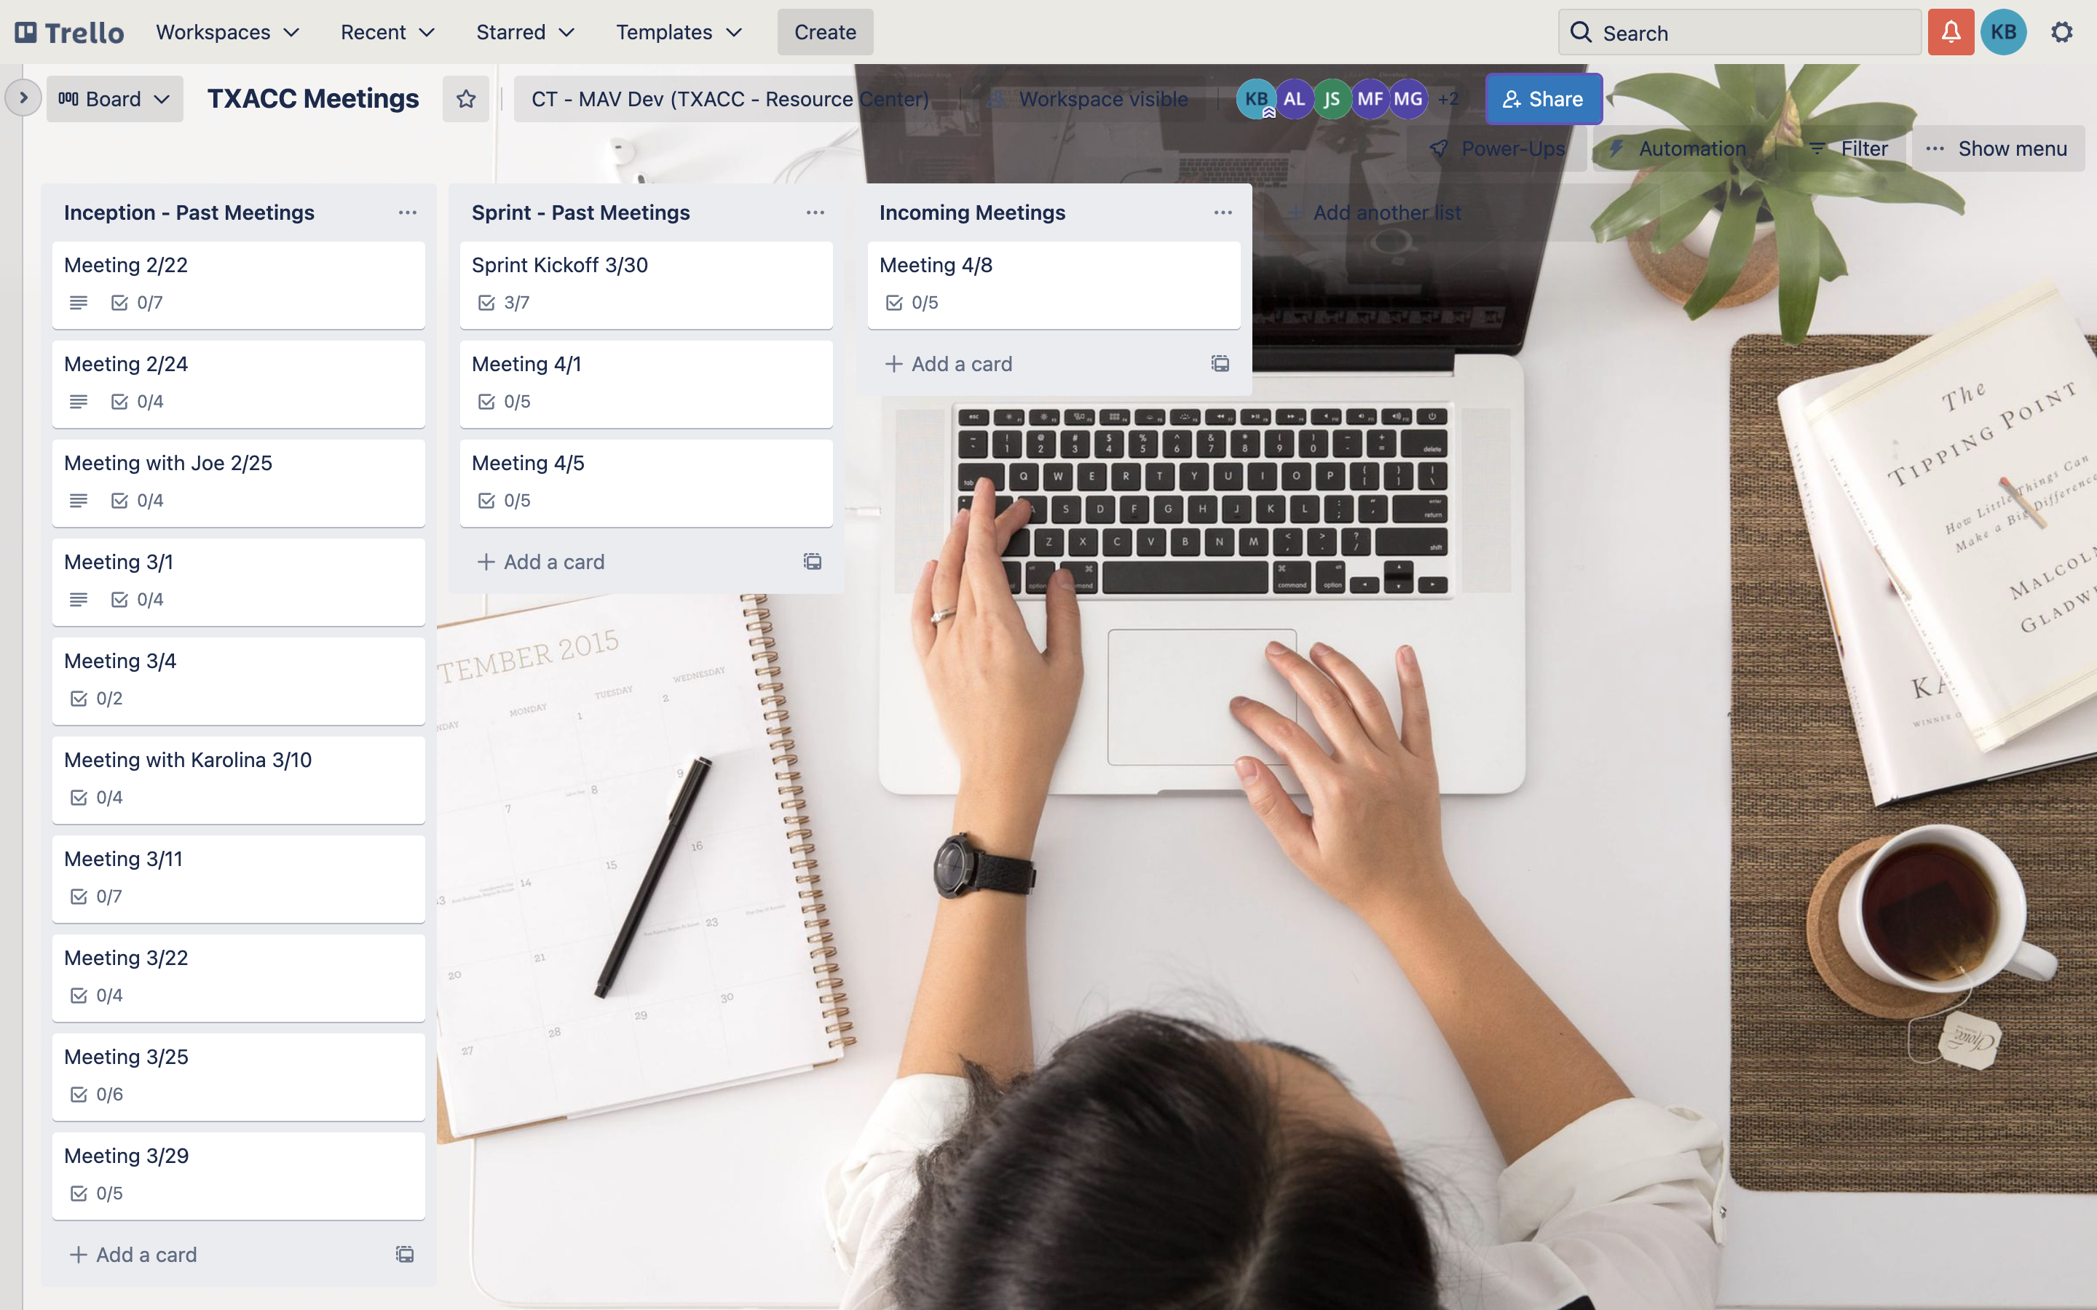

For Development:

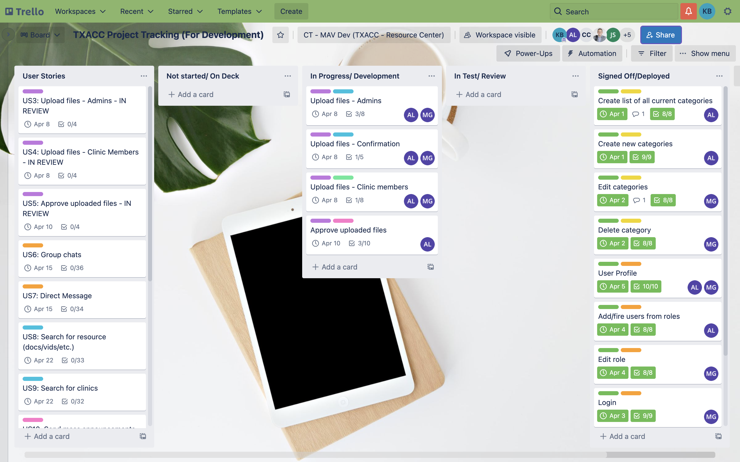

1. **Discussion Agenda**
2. UAT – US 3, 4, 5
3. Training – US 3, 4, 5
4. UI/UX Discussion
5. Sign off
6. Confirm US for Sprint 3
7. Sprint 3 starts